ER Diagram Relational Mapping

Diagram 1: Sports Team Management
- Entities & Relationships: TEAM, PLAYER, INJURY_RECORD (weak entity), HAS, IS_CAPTAIN_OF, HAS_INJURY (identifying relationship), PLAYED (many-to-many relationship).
- Step 1: Strong Entity Sets
  - TEAM(name, city, coach) — Primary Key: name
  - PLAYER(name, position, skill_level, team_name) — Primary Key: name, Foreign Key: team_name references TEAM(name) (from the 1:N HAS relationship).
- Step 2: Weak Entity Sets
  - INJURY_RECORD(injury_id, description, date, player_name) — Primary Key: (injury_id, player_name), Foreign Key: player_name references PLAYER(name).
- Step 3: Binary 1:1 Relationships
  - IS_CAPTAIN_OF: Can be merged into TEAM by adding captain_name as a foreign key referencing PLAYER(name), or kept as a separate relation IS_CAPTAIN_OF(team_name, player_name).
- Step 4: Binary 1:N Relationships
  - Handled in Step 1 (HAS relationship folded into PLAYER via team_name).
- Step 5: Binary M:N Relationships & Multi-Valued Attributes
  - PLAYED(team_name_host, team_name_guest, date, score) — Primary Key: (team_name_host, team_name_guest, date), Foreign Keys: team_name_host and team_name_guest reference TEAM(name).

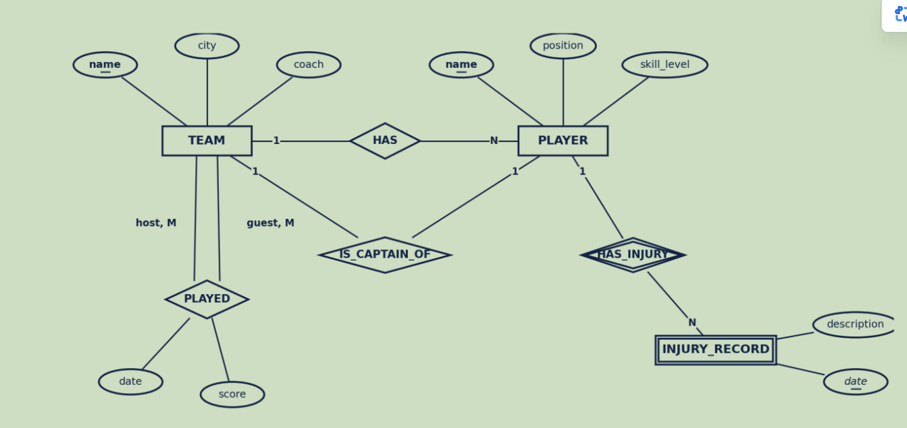

Diagram 2: University Course Registration
- Entities & Relationships: COURSE, COURSE_OFFERING, INSTRUCTOR, STUDENT, PREREQUISITE, OFFERS, TAUGHT_BY, ENROLLS.
- Step 1: Strong Entity Sets
  - COURSE(course_number, title, credits, syllabus) — Primary Key: course_number
  - INSTRUCTOR(instructor_id, name, department, title) — Primary Key: instructor_id
  - STUDENT(student_id, name, program) — Primary Key: student_id
- Step 2: Weak Entity Sets / Composite Attributes
  - COURSE_OFFERING(course_number, semester, section_no, year, classroom, timings) — Primary Key: (course_number, semester, section_no), Foreign Key: course_number references COURSE(course_number).
- Step 3: Binary 1:N Relationships
  - OFFERS is captured by COURSE_OFFERING having course_number as a foreign key.
- Step 4: Recursive / Self-Referencing Relationships
  - PREREQUISITE(course_number, prerequisite_course_number) — Primary Key: (course_number, prerequisite_course_number), Foreign Keys reference COURSE(course_number).
- Step 5: Binary M:N Relationships
  - TAUGHT_BY(instructor_id, course_number, semester, section_no) — Foreign Keys reference INSTRUCTOR and COURSE_OFFERING.
  - ENROLLS(student_id, course_number, semester, section_no, grade) — Foreign Keys reference STUDENT and COURSE_OFFERING.

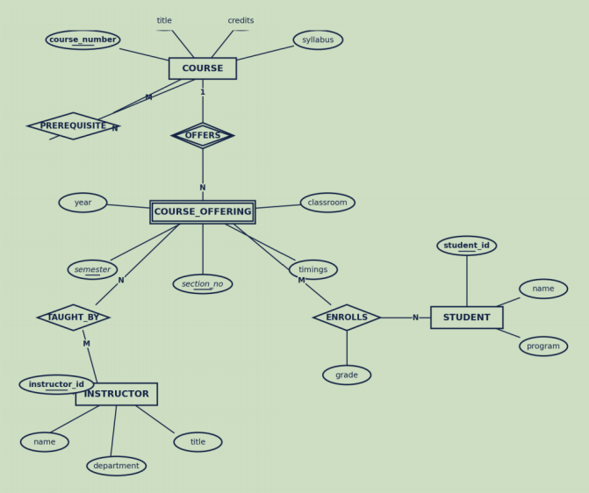

Diagram 3: Car Insurance System
- Entities & Relationships: CUSTOMER, CAR, ACCIDENT, OWNS, INVOLVED_IN.
- Step 1: Strong Entity Sets
  - CUSTOMER(customer_id, name, phone) — Primary Key: customer_id
  - CAR(license_plate, model, year, customer_id) — Primary Key: license_plate, Foreign Key: customer_id references CUSTOMER(customer_id) (from the 1:N OWNS relationship).
  - ACCIDENT(accident_id, date, location, description) — Primary Key: accident_id
- Step 2: Multi-Valued Attributes
  - Since CUSTOMER has a multi-valued attribute address:
  - CUSTOMER_ADDRESS(customer_id, address) — Primary Key: (customer_id, address), Foreign Key: customer_id references CUSTOMER(customer_id).
- Step 3: Binary 1:1 / 1:N Relationships
  - OWNS (1:N) is mapped by including customer_id inside the CAR table.
- Step 4: Binary M:N Relationships
  - INVOLVED_IN(license_plate, accident_id) — Primary Key: (license_plate, accident_id), Foreign Keys reference CAR(license_plate) and ACCIDENT(accident_id).
- Step 5: Integration Check
  - Final validation of primary and foreign key constraints across CUSTOMER, CUSTOMER_ADDRESS, CAR, ACCIDENT, and INVOLVED_IN.

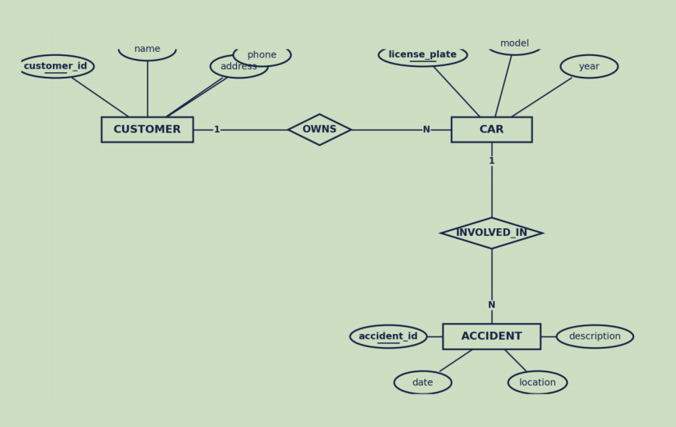

Diagram 4: Hospital Management System
- Entities & Relationships: PATIENT, DOCTOR, TEST_LOG (weak entity), TREATED_BY, UNDERGOES.
- Step 1: Strong Entity Sets
  - PATIENT(patient_id, name, dob, address) — Primary Key: patient_id
  - DOCTOR(doctor_id, specialization) — Primary Key: doctor_id
- Step 2: Weak Entity Sets
  - TEST_LOG(test_id, test_name, date, result, patient_id) — Primary Key: (test_id, patient_id), Foreign Key: patient_id references PATIENT(patient_id).
- Step 3: Binary 1:N Relationships
  - UNDERGOES (1:N between PATIENT and TEST_LOG) is handled by including patient_id in TEST_LOG.
- Step 4: Binary M:N Relationships
  - TREATED_BY (M:N between PATIENT and DOCTOR with attributes date and diagnosis):
  - TREATED_BY(patient_id, doctor_id, date, diagnosis) — Primary Key: (patient_id, doctor_id, date), Foreign Keys reference PATIENT(patient_id) and DOCTOR(doctor_id).
- Step 5: Schema Cleanup & Constraints
  - Ensure all primary keys are underlined/defined and foreign key referential integrity constraints are explicitly specified.

